Charlie Qu

Period 0-2

Mason/Hansen

10/30/23

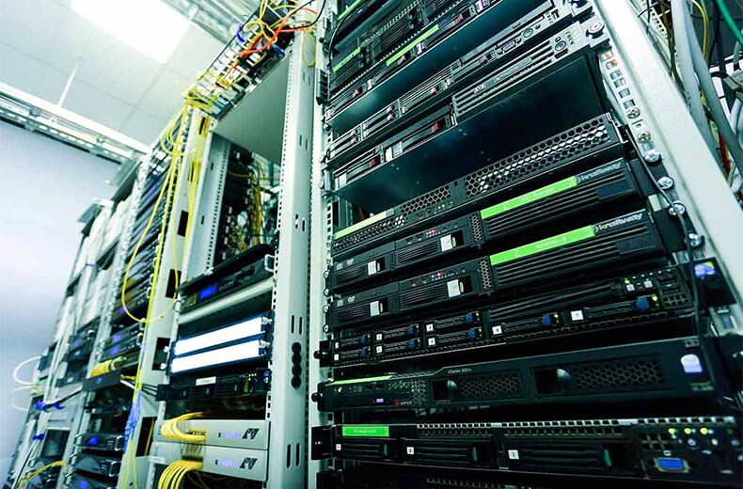

Border Gateway Protocol Lab



Purpose:

Establish Border Gateway Protocol (BGP) configurations for both IPv4 and IPv6, and share routes from Open Shortest Path First (OSPF) and Enhanced Interior Gateway Routing Protocol (EIGRP). Furthermore, understand and configure basic criteria for determining the optimal paths in the network.

Background Information:

BGP, also known as Border Gateway Protocol, exhibits similarities with OSPF and EIGRP. Essentially, it serves as a communication protocol for routers, enabling each router to construct a comprehensive map of the network. What sets BGP apart is its crucial role in the seamless operation of the internet. Given the dynamic nature of the internet, where servers, routers, and devices need to connect randomly, each router must maintain its own automatically generated map. BGP facilitates communication among routers by adhering to a common standard to construct this map.

Every BGP router is assigned an Autonomous System Number (AS), acting as an identifier in the BGP topology. This AS is comparable to the process ID in OSPF, influencing the configuration. Importantly, only one BGP process (and thus one AS) can exist on a router at any given time.

BGP is divided into two types: external BGP (eBGP) and internal BGP (iBGP). eBGP is utilized for internet connections over expansive areas, involving intricate networks. Each router in eBGP must possess a unique AS number, capped at 65535. Conversely, iBGP allows routers to share an AS but necessitates them to be directly connected.

Unlike OSPF and EIGRP, BGP, which connects extensive networks, employs multiple layers of criteria for selecting the best route, known as path attributes. These attributes utilize different metrics and are measured uniquely, forming a prioritized routing list. In this context, three specific path attributes—Weight, Local Preference, and Router ID—were chosen for customization.

Weight, the top-priority path attribute, is a Cisco proprietary attribute manually configured on one router for another next hop. It remains exclusive to the configuring router and is not shared with others. Local Preference, the next-highest priority attribute after Weight, is configured on the router and communicated to all iBGP routers sharing the same AS. It proves to be a useful and straightforward method for prioritizing specific routers, particularly effective within iBGP.

Router ID prioritization centers on selecting the lowest BGP router ID. This ID can be manually set, but in this instance, the router automatically determines it based on the highest loopback IPv4 address or, if unavailable, the highest IPv4 interface address. This prioritization ensures consistent route selection across BGP resets or router reloads, superseding the preference for the oldest route. While it may impact network stability during interface flaps, the decision to utilize the "bgp bestpath compare-routerid" command requires consideration in future networks.

Lab Summary:

We configured BGP settings across four routers, with R1, R2, and R3 forming a direct connection through a switch, and the fourth router, R4, connecting to the others through R1 and R3. The loopback interfaces of R2 and R3 were configured with OSPF and EIGRP. Notably, the link between R1 and R4 was set up using iBGP instead of eBGP as part of an experimental setup. Specific adjustments were made, such as establishing a local preference of 500 on R1 and assigning a weight of 30000 to the link between R3 and R4, leading to its deprioritization. Intentional configurations were also implemented on R1, R3, and R4 to integrate router-ids into the BGP path selection algorithm.

Both IPv4 and IPv6 addresses were configured for the networks, and BGP was activated for both address types. AS 14 was assigned to Routers R1 and R4 to facilitate iBGP, while AS 2 and AS 3 were assigned to R2 and R3, respectively.

Lab Commands:

* Initiate the creation of a BGP process by using the command "router bgp [AS-number]."
* In the default (config-router)# mode, enable the establishment of distributed BGP routes with neighbors by employing the command "neighbor [IPv4 or IPv6 address] remote-as [AS-number]."
* Ensure proper reception and redistribution of BGP routes among neighbors by using the "neighbor [IPv4 or IPv6 address] activate" command. It's crucial to note that while this command seamlessly functions for IPv4 in the (config-router)# mode, for IPv6, configuration in the (config-router-af)# mode is necessary to prevent constant console log messages.
* Switch the BGP configuration from the default IPv4 to IPv6 with the command "address-family ipv6."
* Improve debugging capabilities by implementing the "bgp log-neighbor-changes" command, which outputs BGP neighbor changes to the console.
* Employ the "bgp redistribute-internal" command to redistribute learned OSPF and EIGRP routes into BGP, facilitating the integration of internal routing information.

Network Diagram:

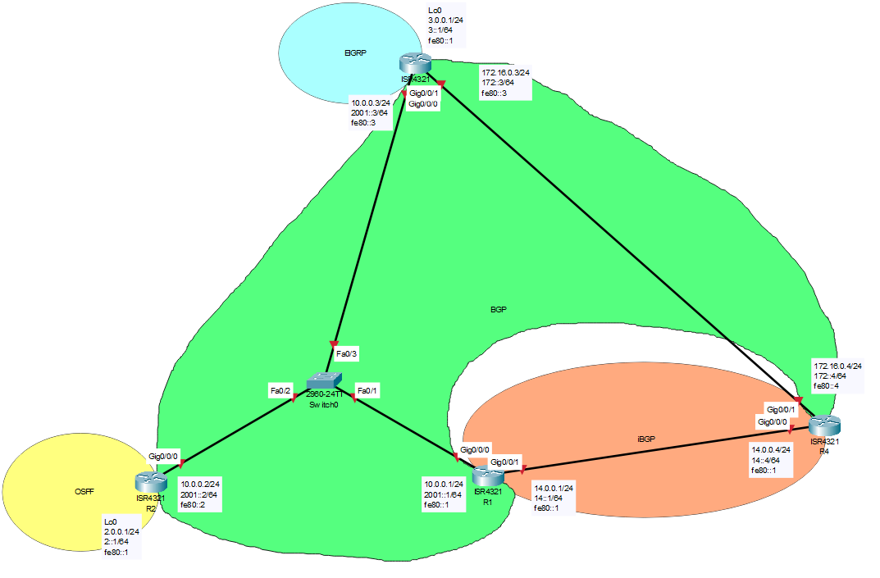

Configurations:

**Configuration, in order: R1, R2, R3, R4**

|  |
| --- |
| en  erase startup-config  conf t  no ip domain-loo  ban motd #Authorized Access Only!#  int g0/0/0  no ipv6 add  int g0/0/1  no ipv6 add  exit  line con 0  loggi sync  exit  ipv6 unicast-r  int g0/0/0  no shut  no ipv6 add  int g0/0/1  no shut  no ipv6 add  exit  host R1  int g0/0/0  ip add 10.0.0.1 255.255.255.0  ipv6 add 2001::1/64  ipv6 add fe80::1 link-l  int g0/0/1  ip add 14.0.0.1 255.255.255.0  ipv6 add 14::1/64  ipv6 add fe80::10 link-l  router bgp 14  network 10.0.0.0 mask 255.255.255.0  network 14.0.0.0 mask 255.255.255.0  bgp log-neighbor-changes  nei 10.0.0.2 remote-as 2  nei 10.0.0.3 remote-as 3  nei 14.0.0.4 remote-as 14  bgp default local-preference 500  bgp bestpath compare-routerid  nei 2001::2 remote-as 2  nei 2001::3 remote-as 3  nei 14::4 remote-as 14  address-family ipv6  network 2001::/64  network 14::/64  nei 2001::2 activate  nei 2001::3 activate  nei 14::4 activate |
| hostname R2  !  no ip domain-lookup  !  interface Loopback0  no shut  ip address 2.0.0.1 255.255.255.0  ipv6 address FE80::1 link-local  ipv6 address 2::1/64  ipv6 ospf 2 area 0  !  interface GigabitEthernet0/0/0  no shut  ip address 10.0.0.2 255.255.255.0  negotiation auto  ipv6 address FE80::2 link-local  ipv6 address 2001::2/64  !  router ospf 2  no shut  redistribute bgp 2 subnets  network 2.0.0.0 0.0.0.255 area 1  !  router bgp 2  bgp log-neighbor-changes  neighbor 10.0.0.1 remote-as 14  neighbor 10.0.0.3 remote-as 3  neighbor 2001::1 remote-as 14  neighbor 2001::3 remote-as 3  !  address-family ipv4  network 10.0.0.0 mask 255.255.255.0  redistribute ospf 2  neighbor 10.0.0.1 activate  neighbor 10.0.0.3 activate  no neighbor 2001::1 activate  no neighbor 2001::3 activate  exit-address-family  !  address-family ipv6  redistribute ospf 2 include-connected  neighbor 2001::1 activate  neighbor 2001::3 activate  exit-address-family  !  ipv6 router ospf 2  no shut  redistribute bgp 2 metric 20 |
| en  conf t  no ip domain-loo  erase startup-config  ban motd #Authorized Access Only!#  int g0/0/0  no ipv6 add  int g0/0/1  no ipv6 add  exit  line con 0  loggi sync  exit  ipv6 unicast-r  host R3  router eigrp 3  no shut  network 3.0.0.1 0.0.0.255  redistribute bgp 3  ipv6 router eigrp 3  no shut  redistribute bgp 3 metric 100 1 255 1 1500  int lo0  no shut  ip add 3.0.0.1 255.255.255.0  ipv6 add 3::1/64  ipv6 add fe80::1 link-l  ipv6 eigrp 3  int g0/0/0  no shut  ip add 10.0.0.3 255.255.255.0  ipv6 add 2001::3/64  ipv6 add fe80::3 link-l  int g0/0/1  no shut  ip add 172.16.0.3 255.255.255.0  ipv6 add 172::3/64  ipv6 add fe80::3 link-l  router bgp 3  bgp log-neighbor-changes  bgp redistribute-internal  network 10.0.0.0 mask 255.255.255.0  network 172.16.0.0 mask 255.255.255.0  nei 172.16.0.4 remote-as 14  nei 10.0.0.2 remote-as 2  nei 10.0.0.1 remote-as 14  redis eigrp 3  nei 172.16.0.4 weight 30000  bgp bestpath compare-routerid  nei 2001::1 remote-as 14  nei 2001::2 remote-as 2  nei 172::4 remote-as 14  address-family ipv6  bgp redistribute-internal  redis eigrp 3 include-connected  network 2001::/64  network 172::/64  nei 2001::1 activate  nei 2001::2 activate  nei 172::4 activate |
| en  conf t  no ip domain-loo  erase startup-config  ban motd #Authorized Access Only!#  int g0/0/0  no ipv6 add  int g0/0/1  no ipv6 add  exit  line con 0  loggi sync  exit  ipv6 unicast-r  host R4  int g0/0/1  no shut  ip add 172.16.0.4 255.255.255.0  ipv6 add 172::4/64  ipv6 add fe80::4 link-l  int g0/0/0  no shut  ip add 14.0.0.4 255.255.255.0  ipv6 add 14::4/64  ipv6 add fe80::4 link-l  router bgp 14  bgp log-neighbor-changes  network 14.0.0.0 mask 255.255.255.0  network 172.16.0.0 mask 255.255.255.0  nei 172.16.0.3 remote-as 3  nei 14.0.0.1 remote-as 14  bgp bestpath compare-routerid  nei 172::3 remote-as 3  nei 14::1 remote-as 14  address-family ipv6  network 172::/64  network 14::/64  nei 172::3 activate  nei 14::1 activate |

## **sh ip route - R1, R2, R3, R4**

|  |
| --- |
| Codes: L - local, C - connected, S - static, R - RIP, M - mobile, B - BGP  D - EIGRP, EX - EIGRP external, O - OSPF, IA - OSPF inter area  N1 - OSPF NSSA external type 1, N2 - OSPF NSSA external type 2  E1 - OSPF external type 1, E2 - OSPF external type 2  i - IS-IS, su - IS-IS summary, L1 - IS-IS level-1, L2 - IS-IS level-2  ia - IS-IS inter area, * - candidate default, U - per-user static route  o - ODR, P - periodic downloaded static route, H - NHRP, l - LISP  a - application route  + - replicated route, % - next hop override, p - overrides from PfR  Gateway of last resort is not set  2.0.0.0/24 is subnetted, 1 subnets  B 2.0.0.0 [20/0] via 10.0.0.2, 00:06:59  3.0.0.0/24 is subnetted, 1 subnets  B 3.0.0.0 [20/0] via 10.0.0.3, 00:23:08  10.0.0.0/8 is variably subnetted, 2 subnets, 2 masks  C 10.0.0.0/24 is directly connected, GigabitEthernet0/0/0  L 10.0.0.1/32 is directly connected, GigabitEthernet0/0/0  14.0.0.0/8 is variably subnetted, 2 subnets, 2 masks  C 14.0.0.0/24 is directly connected, GigabitEthernet0/0/1  L 14.0.0.1/32 is directly connected, GigabitEthernet0/0/1  172.16.0.0/24 is subnetted, 1 subnets  B 172.16.0.0 [200/0] via 14.0.0.4, 00:23:12 |
| Codes: L - local, C - connected, S - static, R - RIP, M - mobile, B - BGP  D - EIGRP, EX - EIGRP external, O - OSPF, IA - OSPF inter area  N1 - OSPF NSSA external type 1, N2 - OSPF NSSA external type 2  E1 - OSPF external type 1, E2 - OSPF external type 2  i - IS-IS, su - IS-IS summary, L1 - IS-IS level-1, L2 - IS-IS level-2  ia - IS-IS inter area, * - candidate default, U - per-user static route  o - ODR, P - periodic downloaded static route, H - NHRP, l - LISP  a - application route  + - replicated route, % - next hop override, p - overrides from PfR  Gateway of last resort is not set  2.0.0.0/8 is variably subnetted, 2 subnets, 2 masks  C 2.0.0.0/24 is directly connected, Loopback0  L 2.0.0.1/32 is directly connected, Loopback0  3.0.0.0/24 is subnetted, 1 subnets  B 3.0.0.0 [20/0] via 10.0.0.3, 00:05:29  10.0.0.0/8 is variably subnetted, 2 subnets, 2 masks  C 10.0.0.0/24 is directly connected, GigabitEthernet0/0/0  L 10.0.0.2/32 is directly connected, GigabitEthernet0/0/0  14.0.0.0/24 is subnetted, 1 subnets  B 14.0.0.0 [20/0] via 10.0.0.1, 00:05:29  172.16.0.0/24 is subnetted, 1 subnets  B 172.16.0.0 [20/0] via 10.0.0.3, 00:05:29  14.0.0.0/24 is subnetted, 1 subnets  B 14.0.0.0 [20/0] via 10.0.0.1, 00:05:29  172.16.0.0/24 is subnetted, 1 subnets  B 172.16.0.0 [20/0] via 10.0.0.3, 00:05:29 |
| Codes: L - local, C - connected, S - static, R - RIP, M - mobile, B - BGP  D - EIGRP, EX - EIGRP external, O - OSPF, IA - OSPF inter area  N1 - OSPF NSSA external type 1, N2 - OSPF NSSA external type 2  E1 - OSPF external type 1, E2 - OSPF external type 2  i - IS-IS, su - IS-IS summary, L1 - IS-IS level-1, L2 - IS-IS level-2  ia - IS-IS inter area, * - candidate default, U - per-user static route  o - ODR, P - periodic downloaded static route, H - NHRP, l - LISP  a - application route  + - replicated route, % - next hop override, p - overrides from PfR    Gateway of last resort is not set    2.0.0.0/24 is subnetted, 1 subnets  B 2.0.0.0 [20/0] via 10.0.0.2, 00:08:30  3.0.0.0/8 is variably subnetted, 2 subnets, 2 masks  C 3.0.0.0/24 is directly connected, Loopback0  L 3.0.0.1/32 is directly connected, Loopback0  10.0.0.0/8 is variably subnetted, 2 subnets, 2 masks  C 10.0.0.0/24 is directly connected, GigabitEthernet0/0/0  L 10.0.0.3/32 is directly connected, GigabitEthernet0/0/0  14.0.0.0/24 is subnetted, 1 subnets  B 14.0.0.0 [20/0] via 10.0.0.1, 00:24:39  172.16.0.0/16 is variably subnetted, 2 subnets, 2 masks  C 172.16.0.0/24 is directly connected, GigabitEthernet0/0/1  L 172.16.0.3/32 is directly connected, GigabitEthernet0/0/1 |
| Codes: L - local, C - connected, S - static, R - RIP, M - mobile, B - BGP  D - EIGRP, EX - EIGRP external, O - OSPF, IA - OSPF inter area  N1 - OSPF NSSA external type 1, N2 - OSPF NSSA external type 2  E1 - OSPF external type 1, E2 - OSPF external type 2  i - IS-IS, su - IS-IS summary, L1 - IS-IS level-1, L2 - IS-IS level-2  ia - IS-IS inter area, * - candidate default, U - per-user static route  o - ODR, P - periodic downloaded static route, H - NHRP, l - LISP  a - application route  + - replicated route, % - next hop override, p - overrides from PfR  Gateway of last resort is not set  2.0.0.0/24 is subnetted, 1 subnets  B 2.0.0.0 [200/0] via 10.0.0.2, 00:08:27  3.0.0.0/24 is subnetted, 1 subnets  B 3.0.0.0 [20/0] via 172.16.0.3, 00:24:37  10.0.0.0/24 is subnetted, 1 subnets  B 10.0.0.0 [200/0] via 14.0.0.1, 00:24:40  14.0.0.0/8 is variably subnetted, 2 subnets, 2 masks  C 14.0.0.0/24 is directly connected, GigabitEthernet0/0/0  L 14.0.0.4/32 is directly connected, GigabitEthernet0/0/0  172.16.0.0/16 is variably subnetted, 2 subnets, 2 masks  C 172.16.0.0/24 is directly connected, GigabitEthernet0/0/1  L 172.16.0.4/32 is directly connected, GigabitEthernet0/0/1 |

## **sh ipv6 route - R1, R2, R3, R4**

|  |
| --- |
| IPv6 Routing Table - default - 8 entries  Codes: C - Connected, L - Local, S - Static, U - Per-user Static route  B - BGP, R - RIP, I1 - ISIS L1, I2 - ISIS L2  IA - ISIS interarea, IS - ISIS summary, D - EIGRP, EX - EIGRP external  ND - ND Default, NDp - ND Prefix, DCE - Destination, NDr - Redirect  O - OSPF Intra, OI - OSPF Inter, OE1 - OSPF ext 1, OE2 - OSPF ext 2  ON1 - OSPF NSSA ext 1, ON2 - OSPF NSSA ext 2, a - Application  B 2::/64 [20/0]  via FE80::2, GigabitEthernet0/0/0  B 3::/64 [20/0]  via FE80::3, GigabitEthernet0/0/0  C 14::/64 [0/0]  via GigabitEthernet0/0/1, directly connected  L 14::1/128 [0/0]  via GigabitEthernet0/0/1, receive  B 172::/64 [200/0]  via 14::4  C 2001::/64 [0/0]  via GigabitEthernet0/0/0, directly connected  L 2001::1/128 [0/0]  via GigabitEthernet0/0/0, receive  L FF00::/8 [0/0]  via Null0, receive |
| Codes: C - Connected, L - Local, S - Static, U - Per-user Static route  B - BGP, R - RIP, I1 - ISIS L1, I2 - ISIS L2  IA - ISIS interarea, IS - ISIS summary, D - EIGRP, EX - EIGRP external  ND - ND Default, NDp - ND Prefix, DCE - Destination, NDr - Redirect  O - OSPF Intra, OI - OSPF Inter, OE1 - OSPF ext 1, OE2 - OSPF ext 2  ON1 - OSPF NSSA ext 1, ON2 - OSPF NSSA ext 2, a - Application  C 2::/64 [0/0]  via Loopback0, directly connected  L 2::1/128 [0/0]  via Loopback0, receive  B 3::/64 [20/0]  via FE80::3, GigabitEthernet0/0/0  B 14::/64 [20/0]  via FE80::1, GigabitEthernet0/0/0  B 172::/64 [20/0]  via FE80::3, GigabitEthernet0/0/0  C 2001::/64 [0/0]  via GigabitEthernet0/0/0, directly connected  L 2001::2/128 [0/0]  via GigabitEthernet0/0/0, receive  L FF00::/8 [0/0]  via Null0, receive |
| IPv6 Routing Table - default - 9 entries  Codes: C - Connected, L - Local, S - Static, U - Per-user Static route  B - BGP, R - RIP, I1 - ISIS L1, I2 - ISIS L2  IA - ISIS interarea, IS - ISIS summary, D - EIGRP, EX - EIGRP external  ND - ND Default, NDp - ND Prefix, DCE - Destination, NDr - Redirect  O - OSPF Intra, OI - OSPF Inter, OE1 - OSPF ext 1, OE2 - OSPF ext 2  ON1 - OSPF NSSA ext 1, ON2 - OSPF NSSA ext 2, a - Application  B 2::/64 [20/0]  via FE80::2, GigabitEthernet0/0/0  C 3::/64 [0/0]  via Loopback0, directly connected  L 3::1/128 [0/0]  via Loopback0, receive  B 14::/64 [20/0]  via FE80::1, GigabitEthernet0/0/0  C 172::/64 [0/0]  via GigabitEthernet0/0/1, directly connected  L 172::3/128 [0/0]  via GigabitEthernet0/0/1, receive  C 2001::/64 [0/0]  via GigabitEthernet0/0/0, directly connected  L 2001::3/128 [0/0]  via GigabitEthernet0/0/0, receive  L FF00::/8 [0/0]  via Null0, receive |
| IPv6 Routing Table - default - 8 entries  Codes: C - Connected, L - Local, S - Static, U - Per-user Static route  B - BGP, R - RIP, I1 - ISIS L1, I2 - ISIS L2  IA - ISIS interarea, IS - ISIS summary, D - EIGRP, EX - EIGRP external  ND - ND Default, NDp - ND Prefix, DCE - Destination, NDr - Redirect  O - OSPF Intra, OI - OSPF Inter, OE1 - OSPF ext 1, OE2 - OSPF ext 2  ON1 - OSPF NSSA ext 1, ON2 - OSPF NSSA ext 2, a - Application  B 2::/64 [200/0]  via 2001::2  B 3::/64 [20/0]  via FE80::3, GigabitEthernet0/0/1  C 14::/64 [0/0]  via GigabitEthernet0/0/0, directly connected  L 14::4/128 [0/0]  via GigabitEthernet0/0/0, receive  C 172::/64 [0/0]  via GigabitEthernet0/0/1, directly connected  L 172::4/128 [0/0]  via GigabitEthernet0/0/1, receive  B 2001::/64 [200/0]  via 14::1  L FF00::/8 [0/0]  via Null0, receive |

## **traceroute from R4 to R2 Lo0 - IPv4, IPv6**

|  |
| --- |
| Type escape sequence to abort.  Tracing the route to 2.0.0.1  VRF info: (vrf in name/id, vrf out name/id)  1 14.0.0.1 1 msec 1 msec 1 msec  2 10.0.0.2 1 msec * 1 msec |
| Type escape sequence to abort.  Tracing the route to 2::1  1 14::1 1 msec 1 msec 1 msec  2 2001::2 1 msec 1 msec 1 msec |

Problems:

Gaining relevant information about BGP, especially IPv6 BGP, proved challenging as we faced difficulties in identifying the exact combination of commands to meet our objectives. Through thorough research and testing, we successfully identified and implemented the necessary commands, developing a comprehensive understanding of their potential counterproductive effects.

One noteworthy command in the potentially unnecessary category was "no bgp default ipv4-unicast." Despite various IPv6 BGP guides emphasizing its necessity, our initial experiences and concerns hinted at the possibility of disabling IPv4 BGP. However, our observation revealed that both IPv4 and IPv6 operated effectively without this command. To simplify our configuration and ensure the functionality of IPv4 BGP, we chose to omit it in subsequent versions.

Initially, challenges arose in redistributing OSPF and EIGRP routes over IPv6 BGP. A retrospective analysis of earlier labs and configuration files revealed that we had addressed this issue in a previous lab. Including "include-connected" in EIGRP and OSPF redistributions, along with adding "bgp redistribute-internal" to the BGP configuration, resolved the problem.

During the configuration, our consoles were flooded with BGP messages from various IPv6 routers. After reloading and scrutinizing our setup, we identified that the IPv6 neighbor activate commands had inadvertently been placed in the IPv4 section, causing excessive messaging. Rectifying this involved reloading the routers and moving the IPv6 neighbor activate commands after the "address-family ipv6" command.

Approaching the lab's completion, IPv6 BGP experienced sudden failures in specific sections, resulting in unsuccessful pings and the absence of routes to the 172::/64 network from R1 or R2. Upon reviewing configurations, we discovered the unintentional deletion of network commands for IPv6 BGP on certain routers. Correcting this involved reinstating the network commands and ensuring their presence in configurations lacking them, ultimately ensuring the proper redistribution of all networks.

Conclusion:

Getting into BGP was like stepping into a whole new world of challenges. It brought in a bunch of new concepts and setups, and I have to admit, it was a bit tricky to wrap my head around, especially with those not-so-friendly log messages. But you know what's surprising? It wasn't all that different from our adventures with OSPF labs. We ended up using a few familiar commands and falling back on our OSPF knowledge when things got a bit confusing. All in all, getting the hang of BGP, something totally new to me, turned out to be a pretty eye-opening and useful experience.

Lab Signoff:

